Math Problem of the Month
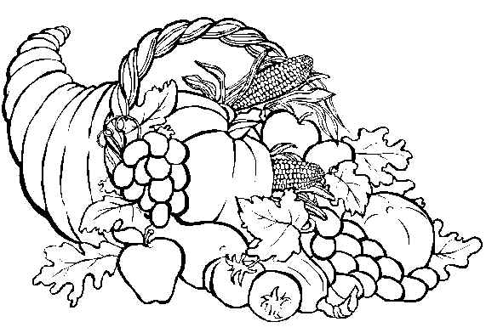
November: A Thanksgiving Feast
Due: Tuesday, November 29 [This is an optional activity]

Project:
You are planning a meal for Thanksgiving for your extended family. Your guests will bring drinks and side dishes. You will provide: one 24-pound turkey, 4 pounds of apples, 6 pounds of carrots, 8 pounds of potatoes, and 3 large pumpkin pies. Use the Internet grocery stores, visit a supermarket, or use grocery store fliers to find the total cost of all items that you will provide for the meal.
Requirements:
- Show all your work, including the cost per pound for food items where applicable, the total cost for each item, and the total cost of the meal.

- Research how long it takes to cook a turkey per pound. If your family is planning to eat dinner at 6pm, what time will you need to start cooking your 24-pound turkey? Explain your thinking.

- Explain how you collected your data and the math you used in completing this project.

- Ask a friend or family member to read your project. Have you used correct spelling, punctuation, capitalization, grammar and paragraphing? Edit your work as needed.

- Prepare a short (5-7 minute) oral presentation in which you will share your project with the class. Present your findings in a creative way! (e.g., poster, multimedia presentation, model, etc.)

