1. Complete the following conversion charts

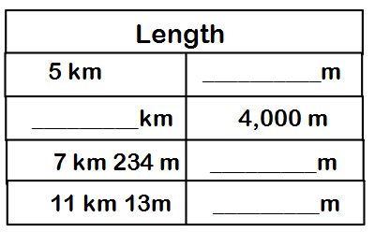

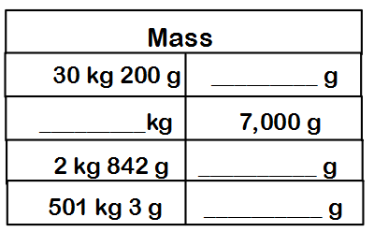
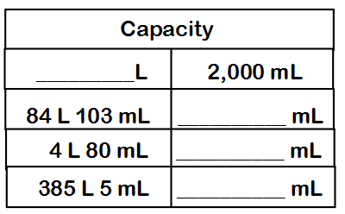

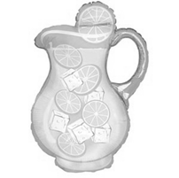
2. Which amount would best describe the amount of lemonade a pitcher holds?

A. 2,000 L
B. 2,000 cm
C. 2,000 kg
D. 2,000 mL

3. Find the sum.
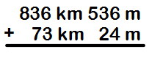

A. 909km 560 m
B. 909km 550 m
C. 809km 550 m
D. 809km 560 m

4. Lance has 6,000 milliliters of soda. How many liters does he have?
A. 6 L B. 60 L
C. 600 L D. 6,000 L

5. Which is the most reasonable estimate for the distance a jogger may run in a day?

A. 2 centimeters B. 2 milliliters
C. 2 meters D. 2 kilometers

6. If a liter bottle is half full of shampoo, how much more shampoo is needed to fill the bottle?

A. 200 mL B. 500 mL
C. 1,000 mL D. 6,000 mL

7. Compare using >, <, or =.
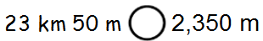

8. Complete the number bond. 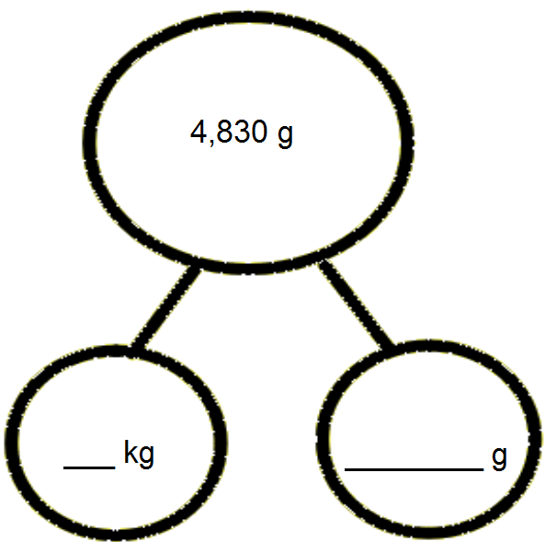

Compare using >, <, or =.

1. 23 km 40 m _____ 2,340 m

2. 13,798 mL _____ 137 L 980 mL

3. 5,607 m _____ 560,701 cm

4. Brandon’s backpack weighs 3,140 grams. Brandon weighs 22 kilograms 610 grams more than his backpack. If Brandon stands on a scale wearing his backpack, what will the weight read?

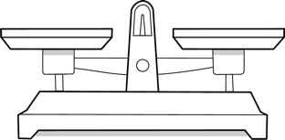
5. Jeff places a pineapple with a mass of 890 grams on a balance scale. He balances the scale by placing two oranges, an apple, and a lemon on the other side. Each orange weighs 280 grams. The lemon weighs 195 grams less than each orange. What is the mass of the apple?

6. Brian is 1 meter 87 centimeters tall. Bonnie is 58 centimeters shorter than Brian. Betina is 26 centimeters taller than Bonnie. How tall is Betina?

