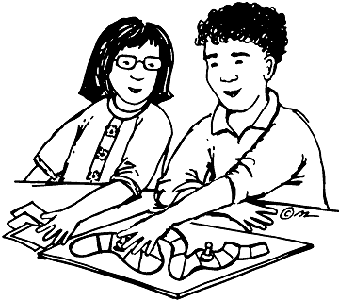
Design a Math Game Project
This is an optional* activity, but all students are encouraged to participate

You are a board game designer. You are creating a game for your classmates to play. Your game can focus on the concepts we have learned in our current math unit or include concepts from the units we have covered prior to this unit.

Requirements:

- Provide clear written directions so players will understand how to play your game.

- Make an answer key to go with your game so players will be able to check their thinking.

- Write a brief description explaining how this game can help students improve their math skills and understandings.

- Use correct spelling, punctuation, grammar and capitalization in all sections of your game and your game description.

- Be sure to present our game in a creative and engaging way!

